

Sample Visual Arts Assessment

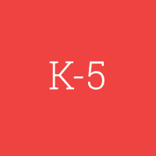

Student Booklet
Proctor Booklet
Scoring Rubrics

Spring 2014



NOTE FROM ARTS ACHIEVE

This performance assessment was developed by staff from Studio in a School in conjunction with the New York City Department of Education’s Visual Arts Coordinator. This packet contains the student assessment booklet, proctor booklet, and rubrics used to score each task.

The Arts Achieve assessments were developed for the specific purpose of measuring students’ overall achievement as a class. Results will reveal gaps in student learning and provide insight into how students can progress toward recognized standards. In this way, the assessment results can also be used to measure teacher effectiveness. It is NOT the intention for this assessment to be used to grade individual students.

In the Visual Arts assessment, students demonstrate their knowledge of art, both in writing and by making artworks in various media. Reproductions of visual artworks serve as prompts throughout. The assessment process includes a partnered discussion.

Discipline-Based Performance Tasks
- Students draw various kinds of lines and textures to demonstrate understanding of the concepts.
- They create a work of art in a given medium (e.g., drawing, collage, painting) within set parameters, following clear instructions.

Written Performance Tasks
- Differentiate types of lines, textures, colors, tints, shades, shapes, values, and forms.
- Explain how elements of art and principles of design create an effect.
- Decode an exhibition label.
- Recognize periods of art.
- Interpret a work of art and write about artistic process.

The Visual Arts assessments utilize a wide variety of masterworks; historical, contemporary, and student-generated. Arts Achieve obtained the rights to use museum artwork in several of the tasks, but we are unable to distribute them in this packet. We have inserted notes on our masterwork selection throughout the assessment. Though we are unable to share many of the pieces, these or comparable works can be found using other resources. For tasks that utilized student work, we have included the same pieces that were used in the original assessment.

While all of the Arts Achieve performance assessments are psychometrically validated and developed against recognized standards, instructors are encouraged to re-interpret and modify tasks to fit their own classes’ needs. We hope this assessment will be useful to your practice and your students!

PART ONE

Drawing Lines and Visual Textures

1. Line is an element of visual arts.
In each box draw the type of line listed above that box.

vertical horizontal diagonal spiral

curved wavy zigzag broken



2. Artists use imaginative patterns of lines to create visual textures that give a lot of details
and describe how something might feel to the touch.

Below is an etching of a rhinoceros by Albrecht Dürer. Dürer used many visual textures including:

scaly hairy prickly/spiky

- Circle the visual textures scaly, hairy and prickly/spiky in the rhinoceros.

NOTE FROM ARTS ACHIEVE:
This task needed an artwork that made clear use of multiple textures. It was important to use work of noted artist as one goal of the assessment is to introduce students to masterworks. We selected Albrecht Dürer’s Rhinoceros (1515).

- Look at the visual textures that you circled on Dürer’s Rhinoceros. Fill the entire box with each visual texture.

scaly hairy prickly/spiky

C. Use your imagination to create one of the visual textures listed below:

furry bumpy rough

WRITE the visual texture you chose on this line: ____________

DRAW the visual texture in this box. -------------------------------→

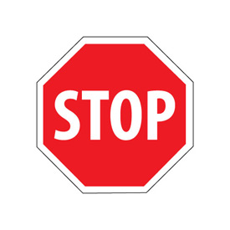

3. Now, let’s put your creativity to work using lines and visual textures!

Use the paper, drawing pencil and gum eraser in your packet to create an interesting animal from your imagination. Use all of the time given to work on your animal.

Remember to:

● Make your animal large enough to fill the whole page or most of the page.

● Turn back and look at the lines you drew on page 3.
Use at least 3 different types of those lines when you create your animal.

● Turn back and look at the visual textures you created on page 5.
Use at least 1 type of those visual textures when you create your animal.

● Use your imagination to create an animal with lots of details and
a unique personality….surprise us!

As you work, check the boxes below to make sure that you are following the directions.

√
I am making my drawing large enough to fill the whole page or most of the page

I am using at least 3 different types of lines I drew on page 3.

I am using at least 1 visual texture I drew on page 5.

I am putting in a lot of details.

I am creating a unique animal from my imagination.

STOP WHEN YOU HAVE FINISHED YOUR IMAGINARY ANIMAL.
Exploring Colors, Tints and Shades

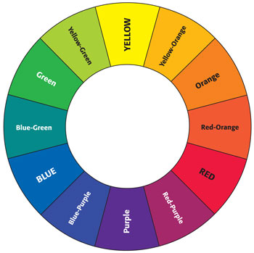

4. Look at the color wheel and list:

The 3 primary colors

The 3 secondary colors

GO ON TO PAGE 8
5. Catherine, a New York City public school student, used many tints and shades of blue to create her painting Early Morning in Manhattan.

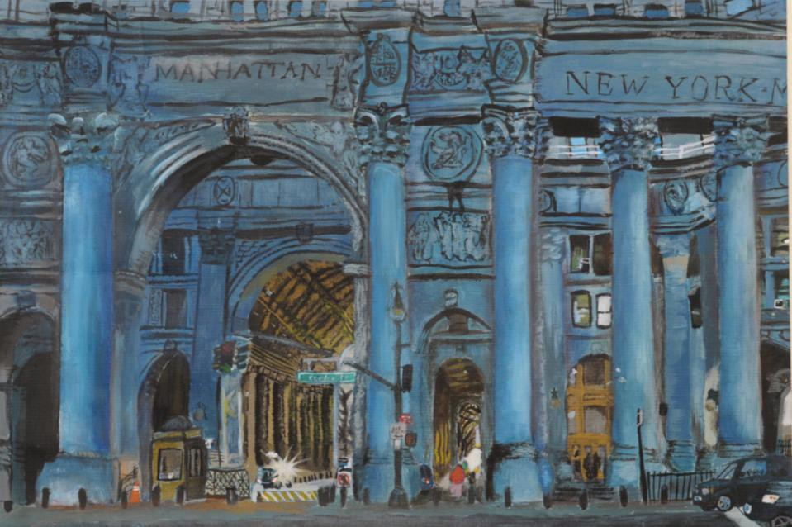

Read these two items about tints and shades. In each one, circle the correct answer.

A. A tint of red is made by:

a. adding white to red

b. adding black to red

c. mixing red with yellow

d. mixing red with purple

B. Circle the box below that is a shade of the blue in this box →

Thinking Like an Artist

6. Artists use the Elements of Art to express their ideas. David is a 5th grade artist and two of the
Elements of Art he used to create Lightning Strikes are line and color.

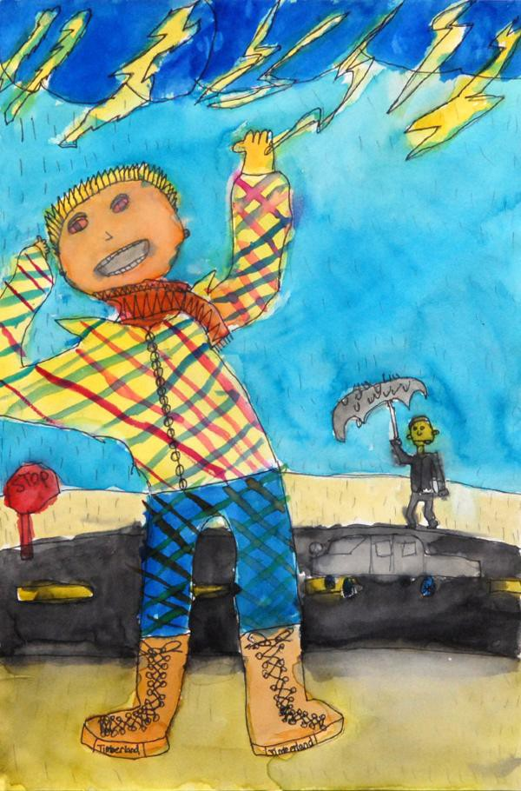

David said:

I wanted the viewer to feel how scary
it is to see lightning.

NOTE FROM ARTS ACHIEVE: For this task, we selected a student work that was narrative and had details that enabled students to briefly write about line and color.

Look closely at David’s painting and then answer the following questions:

How does David use line to show us that it is really scary to see lightning? _________________________________________________________________________________________________________________________________________________________________________________________________________________________________________________________________________________ ___________________________________________________________________________________________
How does David use color to get your attention? ____________________________________________________________________________________________________________________________________________________________________________________________________________________________________________________________________________________________________________________________________________________________________________

Visiting the Art Museum

Museum curators create labels to help visitors learn about works of art on display. The artwork below is in the collection of the Museum of Modern Art in New York City. Next to it is a label a curator might create for this work of art.

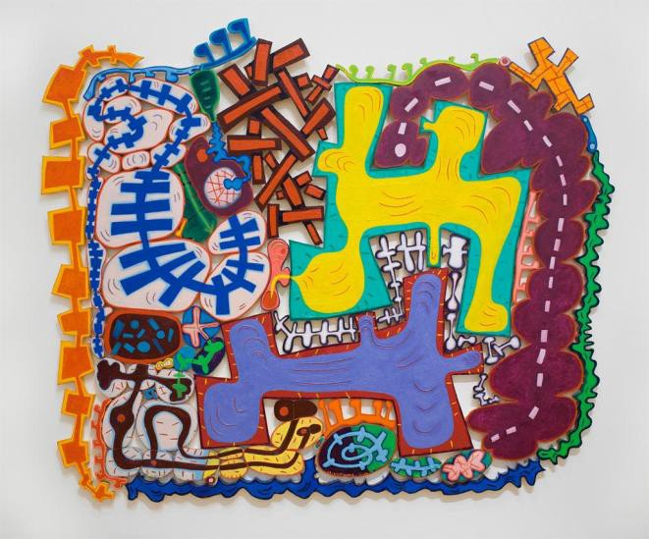
NOTE FROM ARTS ACHIEVE: For this task, we selected Elizabeth Murray’s Do the Dance (2005). This task met our desire to have students learn as they were assessed. Students generally were not familiar with term “curator” and have not had much experience reading labels. Thus, a masterwork with label is required. While not mandatory, this task offered the opportunity to use an abstract work of art.

Do the Dance
2005

Elizabeth Murray
(American, 1940-2007)

Oil on canvas on wood, 9’5” X 11’5”

Gift of Jo Carole and Ronald S. Lauder,
Agnes Gund, and Arne Glimcher

7. Answer these questions by looking at the information on the label above.

What is the name of the artist?
What is the title of the artwork?
What year was the artwork created?
What materials did the artist use to create the work of art?

GO ON TO PAGE 11
Museum curators also plan exhibitions. Imagine that curators wanted to arrange the 4 works below in chronological order. That means from an ancient work done thousands of years ago to work done in more modern times.

8. Number these images 1 to 4, with 1 being the oldest work of art.
Put the numbers on the blanks below each image.

NOTE FROM ARTS ACHIEVE: As in Task 7, this item met our requirement to have students learn as they were assessed; not many 5th graders have thought about the art history continuum. Images used should clearly fall into 4 distinct categories. We used:
- Prehistoric Cave Painting: Two Bisons from Altamira, Spain.
- Ancient Egyptian: Statue of Demedji and Hennutsen
- 19th Century landscape: Vincent van Gogh’s Cypresses (1889)
- 20th Century abstract painting: Stuart Davis’s Composition (1935)

_

Examining Artistic Process

9. You will end the first session by looking at the 2 images below and sharing your ideas with a partner.

With your partner:

• First, look at the top image. Many artists keep sketchbooks as part of their artistic process.
This is a sketch from a page in Edward Hopper’s sketchbook.

• Then, look at the next image. It is Hopper’s finished oil painting.

• Finally, think about this question and discuss it with your partner:

How do you think the sketch helped Hopper to create his painting?
NOTE FROM ARTS ACHIEVE: Images should include a masterwork and a sketch created for that masterwork. For this, we selected an early sketch and the final painting of Nighthawks (1942) by Edward Hopper. This was an ungraded task used for students’ paired discussion about the artist’s process and to set the stage for the next task.

END OF PART ONE

PART TWO

You and a partner just discussed Edward Hopper’s artistic process. In Item 10, we will be looking at the process of a different artist. His name is Pablo Picasso.

10. Below are several photographs of Pablo Picasso at work. Look carefully at the photographs
and then in the box circle the letter of the phrase that best completes the sentence about Picasso.

NOTE FROM ARTS ACHIEVE:
This task required photographs of an artist at work. We selected Pablo Picasso working on various projects in different media.

These images show that Picasso:
a. made only realistic images.
b. enjoyed working in different media.
c. worked with only the human form.
d. did not create any three-dimensional art.

Looking at Collage Artists

The next two pages have collages by Henri Matisse, Romare Bearden, and Eric Carle.
Use them to answer 11, 12 and 13.

11. Look closely at this collage by Matisse. What do you think inspired Matisse and what do you see that
makes you say that?

Write your answer below in complete sentences.

NOTE FROM ARTS ACHIEVE: For “Looking at Collage Artists”, we selected two masterworks and one book illustration dealing with inspiration, geometric/organic shapes, and negative/positive space. Task 11 used Henri Matisse’s Les Codomas (1947).

Matisse, Henri (1869-1954)
© Copyright Jazz, (1947). Portfolio of twenty pochoirs. Composition: various; sheet: 16 3/4 x 25 11/16".
Publisher: Tériade Éditeur, Paris. Printer: Edmond Vairel and DraegerFrères, Paris. Edition: 250.
The Museum of Modern Art, Gift of the artist, 1948. © Succession H. Matisse, Paris / ARS, NY. Location :The Museum of Modern Art, New York, NY, U.S.A.
Photo Credit : Digital Image ©

___________________________________________________________________________________________________________________________________________________________________________________________________________________________________________________________________________________________________________________________________________________________________________________________________________________________________________________________________________________________________________________________________________________________________________________________________________________________________

12. Romare Bearden used geometric and organic shapes in his collage, String Band.

NOTE FROM ARTS ACHIEVE: For “Looking at Collage Artists”, we selected two masterworks and one book illustration dealing with inspiration, geometric/organic shapes, and negative/positive space. Task 12 used Romare Bearden’s String Band (1968).

Name one thing in the collage that is represented by a geometric shape. _________________

Name one thing in the collage that is represented by an organic shape. _____________________

13. In this collage by Eric Carle, place an X on just one area of negative space.
NOTE FROM ARTS ACHIEVE:
For “Looking at Collage Artists”, we selected two masterworks and one book illustration dealing with inspiration, geometric/organic shapes, and negative/positive space. Task 13 used detail of an Eric Carle illustration from “Slowly, Slowly, Slowly,” Said the Sloth.

14. Making Your Own Collage

Earlier you used a drawing pencil and an eraser to create an animal from your imagination. Now you will use paper, scissors, and glue to make a collage of an imaginary animal. It can be the same animal that is in your drawing, or it can be a brand new imaginary animal.

Create a unique animal. Remember you can cut the papers and you also can tear them.
Give your animal some personality and… surprise us!

Remember to:

• Make your animal large enough to fill the whole page or most of the page.

• Choose any color for your base paper.

• Use a variety of colors to help show your animal’s personality

• Cut out geometric and organic shapes to create your animal.

• Experiment with the placement of shapes before you glue them down.

• Arrange your shapes on the base paper making sure that you are creating
interesting positive and negative spaces.

• Paste your collage to the base paper.
(It’s best to put the glue stick on the shape and not on the base paper.)

As you work, check the boxes below to make sure that you are following the directions.

√
I am making my animal large enough to fill the whole page or most of the page.

I am using a variety of colors to help show my animal’s personality.

I am cutting and tearing geometric and organic shapes to create my animal.

I am experimenting with the placement of shapes.

I am creating positive and negative spaces.

My animal is unique and imaginative.

15. Writing about a Museum Work of Art

NOTE FROM ARTS ACHIEVE: Task 15 requires a narrative image with a topic that is accessible to 5th graders. We selected John Sloan’s Backyards, Greenwich Village (1914).

John Sloan liked to paint scenes of New York City. He lived a long time ago, before there were computers, but imagine that he could have received this email from a 5th grade student asking him about his painting Backyards, Greenwich Village. He would enjoy answering these questions. On the next page you will be John Sloan and answer this email:
From: A Friend
To: John Sloan
Subject: I saw your painting at the Whitney Museum of American Art
__________________________________________________________________________________________________
Dear John,

I saw your painting, Backyards, Greenwich Village at the Whitney Museum of American Art. I really liked the way you painted it and I have some questions to ask you.

• Where did you get the idea for this painting?

• What were some of the things you wanted the viewer to notice about your painting?

• While you were painting Backyards, Greenwich Village, what artistic decisions did you have to make?

I hope you can write a long email and answer my three questions with lots of detail.

Thank you, Your Art Friend

Remember these things as you write John’s responses:
• John would give detailed answers to these three questions.
• He would talk about specific parts of his painting.
• He would write in complete sentences.
• He would use words that artists use.
From: John Sloan
To: My Art Friend
Subject: I’m glad you liked Backyards, Greenwich Village. Here are my answers to your three questions: _______________________________________________________________________________________
Dear Art Friend, ________________________________________________________________________________________________________________________________________________________________________________________________________________________________________________________________________________________________________________________________________________________________________________________________________________________________________________________________________________________________________________________________________________________________________________________________________________________________________________________________________________________________________________________________________________________________________________________________________________________________________________________________________________________________________________________________________________________________________________________________________________________________________________________________________________________________________________________________________________________________________________________________________________________________________________________________________________________________________________________________________________________________________________________________________________________________________________________________________________________________________________________________________________________________________________________________________________________________________________________________________________________________________________________________________________________________________________________________________________________________________________________________________________________________________________
Sincerely,
John Sloan

_______________________________________________________________________________________________________________________________________________________________________________________________________

END OF SESSION II

END OF PART TWO


Arts Achieve 5th Grade Visual Arts Assessment
Spring 2014
PROCTOR INSTRUCTIONS

Name | OSIS #
Class
School
Date

SAY Today you will have the chance to demonstrate what you have learned in your art classes. You will be answering questions, and using drawing tools and collage materials. All the materials that you need will be provided.

Assessment booklets will now be given out.

Please use your #2 pencils to fill in the information on the front cover. OSIS #’s will be added later. Read silently as I read aloud A Note to the Student at the bottom of the page

A Note to the Student:
As 5thgraders you have had the opportunity to learn a lot in your art classes. The activities in this
booklet are fun to do and will give you a chance to demonstrate the skills and the understandings you have gained in elementary school. For each item make sure to read the directions carefully and listen carefully to any directions your teacher gives you.

SAY Put your # 2 pencils away. I am going to give each of you a drawing pencil and a packet of materials. Do not open the packet until I tell you to. Your packet contains drawing paper and collage papers. You will be using the drawing paper first and the collage papers later on.

Distribute drawing pencils and packets. Give out the sharpeners as students may need them during the assessment. Do NOT give out the gum erasers at this time.

Open the booklet and fold it back so you are only looking at page 3. You will use your drawing pencil to make lines. Read along silently as I review the instructions for the first activity.

NOTE: The Henri Matisse collage is reprinted with permission of the Museum of Modern Art. All other images, with the exception of student work, are provided through ARTstor with its permission.
PART ONE

Drawing Lines and Visual Textures

1. Line is an element of visual arts.
In each box draw the type of line listed above that box.

SAY If you have any questions as you work on item 1 please raise your hand and I will come to your desk. Note the red stop sign at the bottom of the page. Whenever you see that sign, stop and do not go on to the next page.

vertical horizontal diagonal spiral

curved wavy zigzag broken

Students should be done in 2 minutes. When it looks like they are ready to move on:

SAY Open your booklets to pages 4 and 5. Please read silently as I read the activity. I will guide you to do each section.

Read A and let students complete activity, then repeat with B and C.

SAY If you have any questions as you work please raise your hand and I will come to your desk.


2. Artists use imaginative patterns of lines to create visual textures that give a lot of details and describe how something might feel to the touch.

Below is an etching of a rhinoceros by Albrecht Dürer. Dürer used many visual textures including:

scaly hairy prickly/spiky

A. Circle the visual textures scaly, hairy and prickly/spiky in the rhinoceros.

When all have finished, go on to B.

NOTE FROM ARTS ACHIEVE:
This task needed an artwork that made clear use of multiple textures. It was important to use work of noted artist as one goal of the assessment is to introduce students to masterworks. We selected Albrecht Dürer’s Rhinoceros (1515).
B. Look at the visual textures that you circled on Dürer’s Rhinoceros. Fill the entire box with each visual texture.

scaly hairy prickly/spiky

When all have finished, go on to C.

C. Use your imagination to create one of the visual textures listed below:

furry bumpy rough

WRITE the visual texture you chose on this line:

DRAW the visual texture in this box. -------------------------------→

This should take 5 minutes. When students have finished, distribute the gum erasers and explain that they are for the next drawing activity. Make sure to explain that they are not only used to erase unwanted work; gum erasers may also be used to blend and shade.

SAY Fold your booklet over to page 6 and read along silently as I read aloud.


3. Now, let’s put your creativity to work using lines and visual textures!

Use the paper, drawing pencil and gum eraser in your packet to create an interesting animal from your imagination. Use all of the time given to work on your animal.

Remember to:

● Make your animal large enough to fill the whole page or most of the page.

● Turn back and look at the lines you drew on page 3.
Use at least 3 different types of those lines when you create your animal.

● Turn back and look at the visual textures you created on page 5.
Use at least 1 type of those visual textures when you create your animal.

● Use your imagination to create an animal with lots of details and a unique personality….surprise us!

As you work, check the boxes below to make sure that you are following the directions.

√
I am making my drawing large enough to fill the whole page or most of
the page.
I am using at least 3 different types of lines I drew on page 3.
I am using at least 1 visual texture I drew on page 5.
I am putting in a lot of details.
I am creating a unique animal from my imagination.

Remind students that for the drawing activity, the eraser is not for just erasing what they
don’t want, but it can be used as an art tool itself.

Take out the drawing paper from the packet.

Remember to go back to pages 3 and 5 so you can see your lines and textures.

You will have 20 minutes to create your imaginary animal. I’ll tell you when 5 minutes are left.

STOP WHEN YOU HAVE FINISHED YOUR IMAGINARY ANIMAL.

When time is up:

Write your first and last names on the back of the drawing. Put your drawing pencils, sharpeners and erasers aside and I will collect them. Fold the booklet so that you are looking only at page 7. You will use your #2 pencil to fill in the answers on pages 7 and 8. If you have any questions as
you work please raise your hand and I will come to your desk.

NOTE: Students will need only about 5 minutes to complete these two pages. This is NOT read to the students but you may assist them with language when asked.

As students work, collect drawing pencils, sharpeners and gum erasers.

Exploring Colors, Tints and Shades

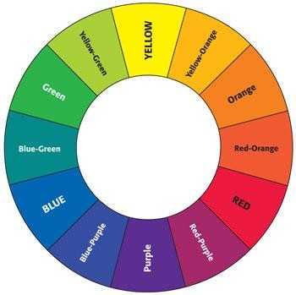

4. Look at the color wheel and list:

The 3 primary colors

The 3 secondary colors

GO ON TO PAGE 8
5. Catherine, a New York City public school student, used many tints and shades of blue to create her painting Early Morning in Manhattan.

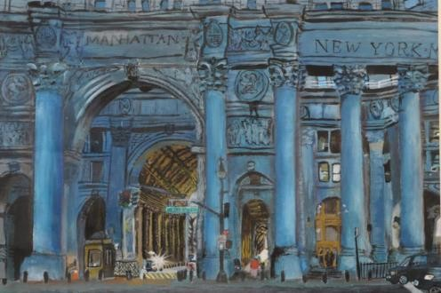

Read these two items about tints and shades. In each one, circle the correct answer.

A. A tint of red is made by:

a. adding white to red b. adding black to red
c. mixing red with yellow

d. mixing red with purple

B. Circle the box below that is a shade of the blue in this box →

When students are done, have them fold the booklet to page 9.

SAY Let’s take a moment to look at the painting on page 9 noticing all the details.

Give students 1 to 2 minutes to look carefully at the painting “Lightning Strikes.”

SAY Now, read silently as I read aloud.

Thinking Like an Artist

6. Artists use the Elements of Art to express their ideas. David is a 5th grade artist and two of the
Elements of Art he used to create Lightning Strikes are line and color.

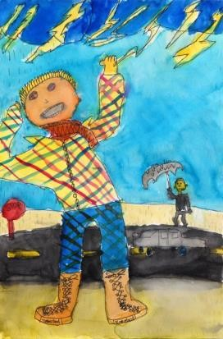
David said:

I wanted the viewer to feel how scary it is to see lightning.
NOTE FROM ARTS ACHIEVE: For this task, we selected a student work that was narrative and had details that enabled students to briefly write about line and color.

Look closely at David’s painting and then answer the following questions:

How does David use line to show us that it is really scary to see lightning?

How does David use color to get your attention?

SAY Remember to write in complete sentences and check your punctuation and spelling.

This should take 5 minutes. When it looks like students are ready to move on:

SAY Turn to page 10 and 11. Read along silently as I read the instructions. Do not begin until we
review both pages….you will have plenty of time to do this!

Don’t read information in the boxes to the students. Read only the blue text. The activities on pages 10 and 11 should take 5 minutes.

Visiting the Art Museum

Museum curators create labels to help visitors learn about works of art on display. The artwork below is in the collection of the Museum of Modern Art in New York City. Next to it is a label a curator
might create for this work of art.

NOTE FROM ARTS ACHIEVE: For this task, we selected Elizabeth Murray’s Do the Dance (2005). This task met our desire to have students learn as they were assessed. Students generally were not familiar with term “curator” and have not had much experience reading labels. Thus, a masterwork with label is required. While not mandatory, this task offered the opportunity to use an abstract work of art.

Do the Dance
2005

Elizabeth Murray
(American, 1940-2007)

Oil on canvas on wood, 9’5” X 11’5”

Gift of Jo Carole and Ronald S. Lauder, Agnes Gund, and Arne Glimcher

7. Answer these questions by looking at the information on the label above.

What is the name of the artist?
What is the title of the artwork?
What year was the artwork created?
What materials did the artist use to create the work of art?

GO ON TO PAGE 11
Museum curators also plan exhibitions. Imagine that curators wanted to arrange the 4 works below in chronological order. That means from an ancient work done thousands of years ago to work done in more modern times.

8. Number these images 1 to 4, with 1 being the oldest work of art.
Put the numbers on the blanks below each image.

NOTE FROM ARTS ACHIEVE: As in Task 7, this item met our requirement to have students learn as they were assessed; not many 5th graders have thought about the art history continuum. Images used should clearly fall into 4 distinct categories. We used:
- Prehistoric Cave Painting: Two Bisons from Altamira, Spain.
- Ancient Egyptian: Statue of Demedji and Hennutsen
- 19th Century landscape: Vincent van Gogh’s Cypresses (1889)
- 20th Century abstract painting: Stuart Davis’s Composition (1935)

At the end of 5 minutes direct students to turn to page 12.

Activity 9 gives students the opportunity to speak to each other about an artist working from sketch to finished work. The discussion will serve as a bridge to Part II. Allow for 5 minutes of conversation.

SAY This next part of the assessment is not graded. It is included to give you the opportunity to talk to a
partner about an artist’s process. Please read along silently as I read aloud.

Examining Artistic Process

9. You will end the first session by looking at the 2 images below and sharing your ideas with a partner.

With your partner:

• First, look at the top image. Many artists keep sketchbooks as part of their artistic process.
This is a sketch from a page in Edward Hopper’s sketchbook.

• Then, look at the next image. It is Hopper’s finished oil painting.

• Finally, think about this question and discuss it with your partner:

How do you think the sketch helped Hopper to create his painting?

NOTE FROM ARTS ACHIEVE: Images should include a masterwork and a sketch created for that masterwork. For this, we selected an early sketch and the final painting of Nighthawks (1942) by Edward Hopper. This was an ungraded task used for students’ paired discussion about the artist’s process and to set the stage for the next task.

At the end of 5 minutes ask for some volunteers to describe what they spoke about…just a minute or
two is needed here.

This is the end of session one. Direct students to close booklets and take a 5-minute break.

END OF PART ONE
PART TWO

NOTE: Students will need only 3 minutes for this activity. Direct them to take out their #2 pencils.

SAY Turn to page 13 and fold the booklet so you are just looking at page 13. Read along silently as I read the text.

Do not read the question in the box unless student asks for assistance.

You and a partner just discussed Edward Hopper’s artistic process. In Item 10, we will be looking at the process of a different artist. His name is Pablo Picasso.

10. Below are several photographs of Pablo Picasso at work. Look carefully at the photographs
and then in the box circle the letter of the phrase that best completes the sentence about Picasso.

NOTE FROM ARTS ACHIEVE:
This task required photographs of an artist at work. We selected Pablo Picasso working on various projects in different media.

These images show that Picasso:
a. made only realistic images.
b. enjoyed working in different media. c. worked with only the human form.
d. did not create any three-dimensional art.

When students have completed this item direct them open the booklet to look at both pages 14 and 15.

SAY Read silently as I read the top of page 14 aloud. You will read the rest of page 14, and then page 15 on your own.
Read only blue text. The rest is not read to the students but you may assist with language when asked. (If students ask about the text below the Matisse work, explain that the work is owned by MoMA who
asked us to list this information as a way of thanking them for allowing us to use the image.)

Looking at Collage Artists

Pages 14 and 15 have questions about the collages of Henri Matisse, Romare Bearden, and Eric Carle.

11. Look closely at this collage by Matisse. What do you think inspired Matisse and what do you see that makes you say that?

Write your answer below in complete sentences.

NOTE FROM ARTS ACHIEVE: For “Looking at Collage Artists”, we selected two masterworks and one book illustration dealing with inspiration, geometric/organic shapes, and negative/positive space. Task 11 used Henri Matisse’s Les Codomas (1947).

Matisse, Henri (1869-1954)
© Copyright Jazz, (1947). Portfolio of twenty pochoirs. Composition: various; sheet: 16 3/4 x 25 11/16".
Publisher: Tériade Éditeur, Paris. Printer: Edmond Vairel and DraegerFrères, Paris. Edition: 250.
The Museum of Modern Art, Gift of the artist, 1948. © Succession H. Matisse, Paris / ARS, NY. Location :The Museum of Modern Art, New York, NY, U.S.A.
Photo Credit : Digital Image ©

Ask students to check that they are writing (1) what they think inspired Matisse and (2) what they see that makes them say that.
12. Romare Bearden used geometric and organic shapes in his collage, String Band.

NOTE FROM ARTS ACHIEVE: For “Looking at Collage Artists”, we selected two masterworks and one book illustration dealing with inspiration, geometric/organic shapes, and negative/positive space. Task 12 used Romare Bearden’s String Band (1968).

Name one thing in the collage that is represented by a geometric shape.

Name one thing in the collage that is represented by an organic shape.

13. In this collage by Eric Carle, place an X on just one area of negative space.

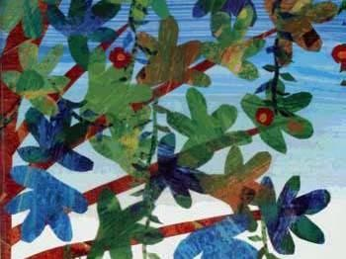
Detail of illustration from “Slowly, Slowly,Slowly,” Said the Sloth

Students should take no longer than 5 minutes to complete these 3 items.

As soon as it looks like they are ready to move on, ask students to put away the #2 pencils. Students should NOT be using any pencils when they work on their collages.

Direct their attention to the collage papers in their packets.

NOTE: Scissors should already be in the classroom. They are not part of the packets.

SAY Now you will be making a collage. You already have your collage papers. The scissors and
glue sticks will be given out after we review the directions. Turn to page 16 and read along silently.

14. Making Your Own Collage

Earlier you used a drawing pencil and an eraser to create an animal from your imagination. Now you will use paper, scissors, and glue to make a collage of an imaginary animal. It can be the same animal that is
in your drawing, or it can be a brand new imaginary animal.

Create a unique animal. Remember you can cut the papers and you also can tear them. Give your animal some personality and… surprise us!

Remember to:

• Make your animal large enough to fill the whole page or most of the page.

• Choose any color for your base paper.

• Use a variety of colors to help show your animal’s personality

• Cut out geometric and organic shapes to create your animal.

• Experiment with the placement of shapes before you glue them down.

• Arrange your shapes on the base paper making sure that you are creating interesting positive and negative spaces.
• Paste your collage to the base paper.
(It’s best to put the glue stick on the shape and not on the base paper.)
As you work, check the boxes below to make sure that you are following the directions.

√
I am making my animal large enough to fill the whole page or most of the page.
I am using a variety of colors to help show my animal’s personality.
I am cutting and tearing geometric and organic shapes to create my animal.
I am experimenting with the placement of shapes.
I am creating positive and negative spaces.
My animal is unique and imaginative.

After you read these directions distribute glue sticks and scissors.

Make sure that all #2 pencils are away. Students are NOT allowed to draw shapes and then cut them out.

SAY You will have 30 minutes to work on your collage. I’ll tell you when you have 5 minutes left. You may begin.

When time is up:

SAY Please put your first and last names on the back of the collage. Put all extra collage papers in the plastic bag. I will now collect the scissors, the glue sticks, and the plastic bags with extra collage papers. Hold on to your collage.

When the collage materials are collected and the collages have been put aside:

SAY Turn to page 18 in your booklets for the last activity.
Direct students to the image of “Backyards, Greenwich Village” on page 18.

SAY This is a painting titled, Backyards, Greenwich Village. It was painted by John Sloan, a famous
American artist.

Let’s spend a few minutes quietly looking at the painting. Notice as many large and small details as you can.

In this final activity you will be given a chance to pretend that you are a famous American artist, John
Sloan. Now, read along silently as I read Activity 15.

15. Writing about a Museum Work of Art
NOTE FROM ARTS ACHIEVE: Task 15 requires a narrative image with a topic that is accessible to 5th graders. We selected John Sloan’s Backyards, Greenwich Village (1914).

John Sloan liked to paint scenes of New York City. He lived a long time ago, before there were computers, but imagine that he could have received this email from a 5th grade student asking him about his painting Backyards, Greenwich Village. He would enjoy answering these questions. On the next page you will be John Sloan and answer this email:

Check to see that all students understand what an email is and that they are going to pretend that even though John Sloan lived many years ago, he could read and send an email.

From: A Friend
To: John Sloan
Subject: I saw your painting at the Whitney Museum of American Art

Dear John,

I saw your painting, Backyards, Greenwich Village at the Whitney Museum of American Art. I really liked the way you painted it and I have some questions to ask you.

• Where did you get the idea for this painting?

• What were some of the things you wanted the viewer to notice about your painting?

• While you were painting Backyards, Greenwich Village, what artistic decisions did you have to make? I hope you can write a long email and answer my three questions with lots of detail.
Thank you, Your Art Friend
Make sure that the students keep the booklets open so that as they write on page 19, they can refer back to the painting on page 19. The following has to be strongly emphasized.

END OF SESSION II

Remember these things as you write John’s responses:
• John would give detailed answers to these three questions.
• He would talk about specific parts of his painting.
• He would write in complete sentences.
• He would use words that artists use.

SAY Remember to use proper punctuation and spelling, and to write in complete sentences. You will have
20 minutes to do this activity.

From: John Sloan
To: My Art Friend
Subject: I’m glad you liked Backyards, Greenwich Village. Here are my answers to your three questions:

Dear Art Friend,

Sincerely, John Sloan

When time is almost up ask students to spend several minutes looking over what they wrote to check their spelling and punctuation. Ask them to make sure they have written in whole sentences.

SAY Session II is over. Please make sure that you have written your first and last name on the back of your drawing and your collage. Place both into your booklet.

Collect assessment materials. Thank students for all of the creative work they have done in both sessions!

END OF PART TWO
i-3 ARTS ACHIEVE
VISUAL ARTS 5th Grade Rubric Spring 2014 Year 3 of Dissemination

TASK | Exceeds Performance Indicators  4 | Meets Performance Indicators  3 | Nears Performance Indicators  2 | Falls Short of Meeting the Performance Indicators 1
1.  Able to identify a variety of lines by drawing the lines named | NOTE: Student is scored from 0 to 8, for the number of lines drawn correctly, and not 1 to 4.
2a.  Able to identify a variety of visual textures in a drawing | XXXXXXXXXXXXXXXXXXXXXXX | Able to identify 3 types of textures. | Able to identify 2 types of textures. | Able to identify 1 type of texture  (0 = no textures identified)
2b.  Able to reproduce visual textures | XXXXXXXXXXXXXXXXXXXXXXX | Creates the 3 types of textures. | Creates 2 of the types of textures. | Creates 1 of the types of textures.  (0 = no textures drawn)
2c.  Able to create a visual texture from several choices | XXXXXXXXXXXXXXXXXXXXXXX | Accurately creates 1 of 3 suggested visual textures. | Approximates 1 of 3 suggested textures | Demonstrates little or no ability to draw 1 of 3 suggested textures.
4a.  Color wheel (Primary Colors):  recognizing and identifying 3 primary colors | xxxxxxxxxxxxxxxxxxxxxxxxxxx | Correctly identifies 3 primary colors | Correctly identifies 2 primary colors | Correctly identifies 1 primary color  (0 = no primary colors identified)
4b.  Color wheel (Secondary Colors):  recognizing and identifying 3 secondary colors | xxxxxxxxxxxxxxxxxxxxxxxxxxxx | Correctly identifies 3 secondary colors | Correctly identifies 2 secondary colors | Correctly identifies 1 secondary color  (0 = no secondary colors identified)
5a.  Identifying a tint of red | xxxxxxxxxxxxxxxxxxxxxxxxxxxxx | Selects correct response to identify how a tint of red is made. | xxxxxxxxxxxxxxxxxxxxxxxxxxxx | Does not select correct response to identify how a tint of red is made.
5b.  Identifying a shade of blue | xxxxxxxxxxxxxxxxxxxxxxxxxxxx | Selects correct response to identify the shade of the blue depicted. | xxxxxxxxxxxxxxxxxxxxxxxxxxxx | Does not select correct response to identify the shade of the blue depicted .
6.  Thinking like an Artist: Lightning Strikes | Proving student has looked deeply at the painting, identifies and specifically describes how David:  - used line to show how scary lightning can be  - used color to get the viewer’s attention | Identifies and adequately describes how David:  - used line to show how scary lightning can be  - used color to get the viewer’s attention | Adequately describes how David used just one of the elements of art below:  - line to show how scary lightning can be  - color to get the viewer’s attention | Does not use an element of art to identify or describe anything in the painting related to either line or color.
7.  Elizabeth Murray chat card | Correctly identifies all 4 items on chart. | Correctly identifies 3 items on chart. | Correctly identifies 2 items on chart. | Correctly identifies only 1 item  (0 = no items correctly identified)
8.  Timeline | xxxxxxxxxxxxxxxxxxxxxxxxxxxx | Able to place all of the artworks in correct chronological order | xxxxxxxxxxxxxxxxxxxxxxxxxxx | Does not place any of the artworks in correct chronological order
9.  Hopper | UNGRADED
10.  Picasso process | Xxxxxxxxxxxxxxxxxxxxxxxxxxxxx | Correctly identifies that Picasso enjoyed working in different media. | xxxxxxxxxxxxxxxxxxxxxxxxxxx | Does not correctly identifies that Picasso enjoyed working in different media.
11.  Pre-Performance Task: Looking at collage artist: Matisse | Writes in specific detail what inspired Matisse and explains what prompted answer. Answer relates to the aspect(s) of the collage the student selects. Answer is written in complete sentences. | Writes what inspired Matisse, and explains what prompted answer but does not describe in a fully detailed way but answer is adequate. Writes in full sentences | Has some difficulty naming what inspired Matisse; tries to articulate, but may not be able to describe why Matisse was inspired by the choice. OR selects an aspect of the collage which doesn’t clearly align with inspiration named. | Does not name inspiration (how he got his ideas).
12.  Pre-Performance Task: Looking at collage artist: Bearden | xxxxxxxxxxxxxxxxxxxxxxxxxxxxx | Able to list 1 thing represented by both:  a geometric shape (chair, violin bow, platform/porch, window frame)  an organic shape  (body of instruments, clothing, leaves) | Able to list 1 thing represented by a geometric shape or 1 thing represented by an organic shape, but not both. | Does not list a thing represented by etiher a geometric shape or an organic shape.
13.  Pre-Performance Task: Looking at collage artist: Carle | xxxxxxxxxxxxxxxxxxxxxxxxxxxxx | Correctly places X on an area of the background of the collage depicting negative space. | xxxxxxxxxxxxxxxxxxxxxxxxxxxxxxxx | Does not correctly place X on an area of the of the collage depicting negative space.

Elementary School Performance Task 3: Drawing
TASK | 4 | 3 | 2 | 1
3.1  Uses Drawing Pencil with Control | Uses the drawing pencil with exceptional control to create an interesting animal from imagination | Uses the drawing pencil with control to create a somewhat interesting animal from imagination | Inconsistent control in creating an interesting animal from imagination; paper may be smudged/messy showing | Shows little control of the drawing pencil to create an animal from imagination
3.2  Draws Animal with High Degree of Detail | Animal has a high degree of imaginative detail; very readable | Animal has imaginative detail in some but not all areas; reads well as an animal | Animal does not have sufficient detail; may not be fully readable (perhaps limited to outline drawing or not distinguishable as an animal) | Animal shows no detail; is not readable as an animal.
3.3  Lines | Uses 3 or more types of lines to make animal exceptionally interesting providing details: fur, hair, facial expression | Uses 3 or more types of lines to providing detail to make animal interesting | Uses 2 or 3 types of lines to make an animal with limited detail. | Uses only 1 type of line to create animal; does not draw a recognizable animal
3.4  Visual Texture | Uses texture to make animal exceptionally interesting; provides details of animal (fur, hair, skin, facial expression, details of other body parts) | Uses texture to make the animal interesting; provides some details | If texture is used, does not provide adequate details, but shows only rudimentary use | Does not use a visual texture to detail drawing
3.5  Composition of Animal | Composes animal to fill the page appropriately so details can be clearly legible | Composes animal large enough to mostly fill the page appropriately; most details are clearly legible | Attempts to compose the animal, but not large enough to clearly see the details and does not fill the page appropriately | Does not compose an animal; does not fill the page appropriately
3.6  Demonstrates Imaginative Capacities | Demonstrates imagination to make animal interesting - animal engaged in an activity, depicted expressively (e.g., realistically, with gesture) | Demonstrates imagination to make the animal somewhat interesting, may or may not be engaged in an activity; depicted somewhat expressively and realistically | Does not fully demonstrate imagination to make animal interesting; attempts to show expressiveness, but in a limited way | Does not demonstrate imagination to make animal interesting; animal not expressive, e.g. no detail, gesture
COMMON CORE  CAPACITY  Responds to Varying Demands of Audience, Task and/or Purpose  Entire task | Skillfully adapts performance according to audience, task, and/or purpose given for task; performance displays strong understanding of nuances and appropriate adjustments in focus and intent. | Attempts to adapt performance according to audience, task and/or purpose, but is not always successful in making appropriate adaptations; displays some understanding of nuances and performance shows some evidence of change in focus and intent. | Performance shows occasional attempts to adapt performance according to audience, task and/or purpose, but these are largely unsuccessful; little change in focus and intent throughout performance; shows occasional inconsistent evidence of understanding nuances. | Performance shows little or no awareness of the audience, task, and/or purpose; little or no change in focus or intent throughout performance; no evidence of understanding of nuances.
Elementary School Performance Task 14: Collage
TASK | 4 | 3 | 2 | 1
14.1  Composition  0f Animal | Fills page appropriately so details can be clearly seen | Fills page appropriately so most details can be clearly seen | Animal not large enough to clearly see details; does not fully fill the page appropriately | Does not compose an animal; does not use the page appropriately
14.2  Expressive  use of Color | Demonstrates ability to thoughtfully choose colors for deliberate effect in creating the animal | Demonstrates ability to thoughtfully choose colors; most colors are chosen for deliberate effect in creating the animal | Demonstrates little ability to choose colors, but choices show a basic understanding of color choice | Demonstrates no ability to use varied color to create the animal
14.3  Expressive  use of Shape | Creates both geometric and organic shapes, using them imaginatively to depict the animal | Creates both geometric and organic shapes, using most shapes imaginatively to depict the animal | Limited effective use of geometric /organic shapes; may use one or the other kind, not both, and may repeat form over and over for all parts of the animal. | Does not use organic or geometric shapes effectively in creation of animal.
14.4  Positive/Negative Space | Interesting and deliberate use of negative and positive space; delineates a clearly created negative space from the positive space | Interesting and deliberate use of negative and positive space; in most cases delineates a clearly created negative space from the positive space | Shows some understanding of depicting negative/positive space relationship, but may have some difficulty depicting it clearly | Collage shows no evidence of a clear positive/negative space relationship between parts of animal or between animal and background
14.5  Handles Materials Competently: Cutting/Tearing | Great facility is shown in cutting and/or tearing shapes (shapes have clean edges if cut or edges are deliberately textured). | Shows facility cutting/tearing shapes (if cut, most edges are clean; if torn, most clean edges are deliberately textured) | Little facility shown in cutting/tearing shapes; some difficulty using scissors as a drawing tool (cut shapes may not have clean edges: shapes may be rudimentary) | No facility is shown in cutting and/or tearing shapes effectively to create collage.
14.6  Handles Materials Competently: Gluing | XXXXXXXXXXXXXXXXXXXXXXXXXX | Great facility is shown with gluing (glue does not show on face of collage; shapes are glued completely down). | Facility is shown with gluing but some glue may show on the face of the collage or shapes may not be completely glued down | Does not have adequate facility with gluing, but attempts to glue down shapes
14.7  Demonstrates Imaginative Capacities | Demonstrates high degree of imagination to make the animal interesting and expressive (animal may be engaged in an activity, depicted in great detail, and expresses its personality extraordinarily well) | Demonstrates imagination to make the animal interesting and expressive (animal may be engaged in an activity, depicted in great detail) | Does not fully demonstrate imagination to make animal interesting and expressive, but attempts to show minimal detail of animal and personality is not clear, but makes an attempt to depict it in a limited way | Does not demonstrate imagination in creation of animal; does not give the animal a personality
COMMON CORE  CAPACITY  Responds to Varying Demands of Audience, Task and/or Purpose  Entire task | Skillfully adapts performance according to audience, task, and/or purpose given for task; performance displays strong understanding of nuances and appropriate adjustments in focus and intent. | Attempts to adapt performance according to audience, task and/or purpose, but is not always successful in making appropriate adaptations; displays some understanding of nuances and performance shows some evidence of change in focus and intent. | Performance shows occasional attempts to adapt performance according to audience, task and/or purpose, but these are largely unsuccessful; little change in focus and intent throughout performance; shows occasional inconsistent evidence of understanding nuances. | Performance shows little or no awareness of the audience, task, and/or purpose; little or no change in focus or intent throughout performance; no evidence of understanding of nuances.

Elementary Writing Rubric - Task 15: A Letter from John Sloan
Criteria | 4 | 3 | 2 | 1 | 0
Content  (demonstrated understanding of content and ideas) | - Identification and description of Sloan’s ideas and processes for the painting reflect fully informed knowledge and understanding of Sloan’s painting; no misapplication of terms is evident  - Examples cited as supporting evidence, reflect full understanding of, and deep looking into, Backyards, Greenwich Village  •Extremely knowledgeable use of art vocabulary | - Identification and description of ideas and processes for the painting mostly reflect an understanding of Sloan’s painting and minor misapplication of terms does not undermine a demonstration of understanding the artwork  - Examples cited as supporting evidence from the work reflect an understanding of Backyards, Greenwich Village  •Knowledgeable use of art vocabulary | - Identification and description of ideas and processes for the painting reflect developing knowledge and understanding of Sloan’s painting; misapplication of terms is evident; indicates developing grasp of the artwork.  - Limited or misapplied examples cited as supporting evidence show developing or weak understanding of Backyards, Greenwich Village  - Limited or incorrect use of art vocabulary | - Identification and description of ideas and processes for the painting do not reflect understanding of Sloan’s artwork and there are terms missing or misapplication of terms are evident.  - Examples cited as supporting evidence do not reflect under-standing of Backyards, Greenwich Village  • No art vocabulary is used. | No response.

Development  (organization and presentation of arguments and ideas) | - Response comprehensively addresses the prompt and is consistent with the task and its purpose and audience; all aspects of the prompt addressed;  - Responses are well-developed and coherently structured with an obvious and engaging opening sentence and relevant supporting detail sentences;  - Ideas are clearly arranged and flow logically from one supporting idea to the next | - Response addresses the prompt and is consistent with the task and its purpose and audience; most aspects of the prompt addressed;  - Responses are adequately developed and coherent; main ideas are supported with relevant detail sentences and examples from the work  - Ideas flow logically from one supporting idea to the next | - Response addresses some elements of the prompt, some consistencies with the task and its purpose and audience evident;  - Responses are underdeveloped; main ideas are incomplete or not fully supported with relevant examples and details from the work  - Some ideas do not flow logically from one supporting point to the next | - Response does not address the prompt and/or is inconsistent with the task and its purpose and audience;  - Responses are undeveloped and lack coherence; main ideas are unclearly formulated; supporting detail sentences do not support main ideas and/or provide unrelated or incorrect evidence  - Ideas are confusing and do not flow logically from one supporting idea to the next | No response

Analysis  (demonstrates quality of argument and evidence presented) | - Narrative related to the artwork is supported with specific and relevant highly evidence from the work  - Keen observations reflect uniquely informed, evidence-based perspective and credible reasoning as if Sloan really knew what he intended in his explanation of his painting | - Narrative related to the artwork is supported evidence from the work  - Observations reflect an informed, evidence-based perspective as if Sloan knew what he was talking about and intended in his explanation of his painting | - Narrative related to the artwork is supported with some evidence from the work  - Incorrect or limited use of examples from the work reflect underdeveloped evidence-based perspective as if Sloan might know not know what he was talking about…this because he didn’t back up his ideas with good explanations and examples from his painting | - Narrative related to the chosen artwork is not supported with specific evidence from the work  - Observations and use of examples from the work do not reflect an informed or evidence-based perspective; examples are missing or unrelated | No response

Writing Conventions | - Response adheres to rules for writing complete sentences; no errors in spelling, end-of-sentence punctuation marks, or capitalization; no sentence fragments or run-ons. Writing is clear and accessible | - Response generally adheres to rules for writing complete sentences; 1 or 2 minor errors in sentence punctuation or spelling does not impact clarity or readability of the response; correct use of end-of-sentence punctuation marks and capitalization applied appropriately | - Response inconsistently adheres to rules for writing complete sentences; more than 2 instances of missing or incorrect punctuation evident; misspellings and/or errors in capitalization; grammatical errors impact readability of response in some instances | - Response does not indicate command or understanding of basic sentence; several instances of incomplete and/or run-on sentences; numerous misspellings and/or errors in capitalization and punctuation impact readability and clarity of the response | No response

